EXPERIMENT 1
Title: Write query to create table Customer and order.
Objective: Create the following tables:
Customer
Column_name | Data type | Size | Constraint
SID | Varchar2 | 4 | Primary Key
First_Name | Char | 20
Last_name | Char | 20

Orders
Column_name | Data type | Size | Constraint
Order_ID | Varchar2 | 4 | Primary Key
Order_date | Char | 20
Customer_SID | Varchar2 | 20 | Foreign Key
Amount | Number |  | Check > 20000

Pre-requisites:
- Knowledge of RDBMS and DBMS
- Sql queries
- DDL query
Query:
Create table Customer(sid varchar(4)primary key,First_Name char(20),Last_Name char(20));
Create table Orders2(Order_id varchar(4) primary key, Order_date char(20), Customer_sid varchar(20) references customer(sid), Amount int check(amount>20000));
Output:
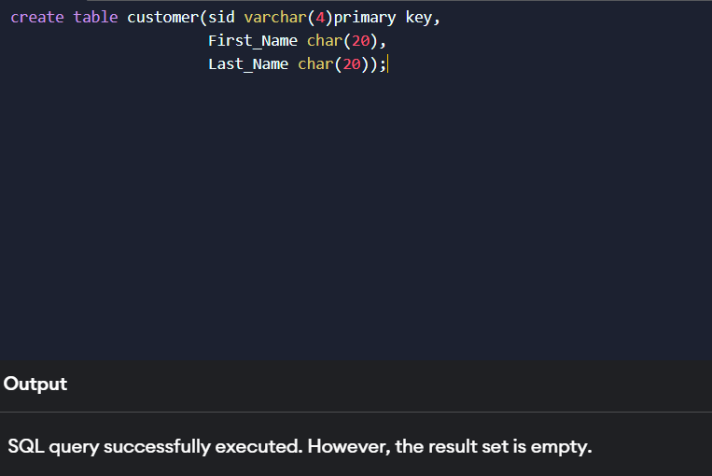

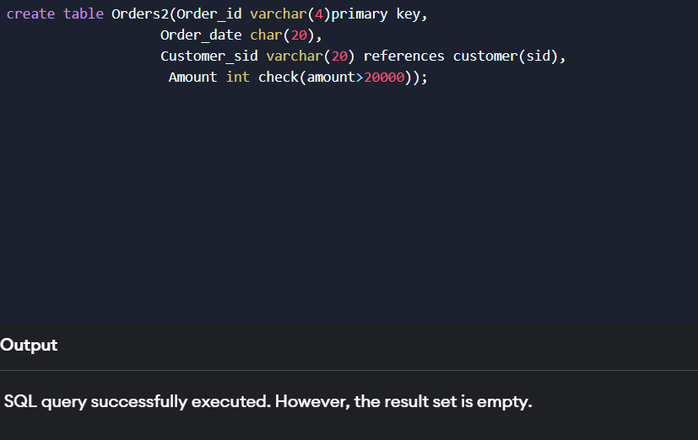

EXPERIMENT 2
Title:Write a query to insert records 5 records in Customer and Order table.
Objective: Insert five records for each table
Pre-requisites:
- Knowledge of SQL queries
- DDL query
Query:
Customer values
insert into customer values('1', 'Arun', 'Kumar');
insert into customer values('2', 'Raja', 'Rogi');
insert into customer values('3', 'Sumit', 'Kumar');
insert into customer values('4', 'Jen', 'Joby');
insert into customer values('5', 'Chinu', 'Gandhi');
Order values
insert into Orders2 values('101', '20-10-2012', '1', 25000);
insert into Orders2 values('A12', '10-09-2024', '5',30000);
insert into Orders2 values('1MK', '25-12-2019','3',55000);
insert into Orders2 values('Gh3', '20-05-2025', '4', 26000);
insert into Orders2 values('KL2', '12-10-2010', '2',25000);

Output:
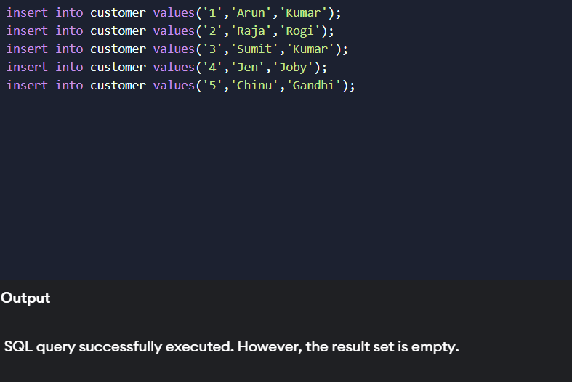
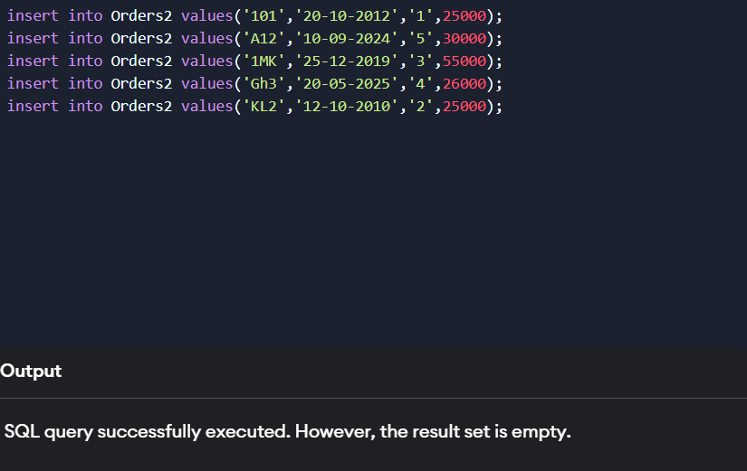

EXPERIMENT 3
Title: Write a query to show all records in table along with their amounts.
Objective: List the details of the customers along with the amount.
Pre-requisites:
- SQL queries
- DML commands
Query:
SELECT customer.sid,customer.First_Name,customer.Last_Name, Orders2.Amount FROM customer
Inner join Orders2 on customer.sid = Orders2.customer_sid;
Output:
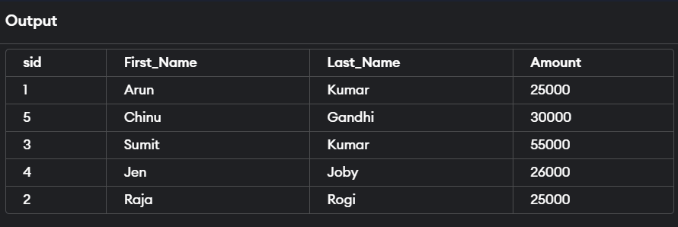

EXPERIMENT 4
Title: Write a query to show records of customer name’s end with a
Objective: List the customers whose names end with “a”.
Pre-requisites:
- SQL queries
- DML queries
Query:
select * from Customer where First_Name like”%a”;
Output:
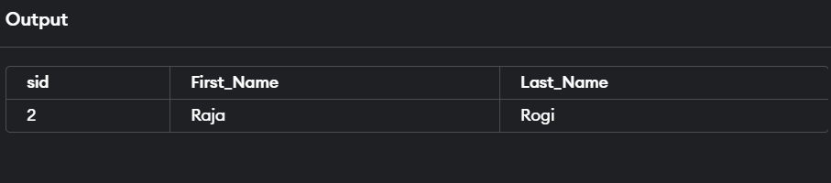

EXPERIMENT 5
Title: Write a query to show records of orders where amount is 21000 and 30000.
Objective: List the orders where amount is between 21000 and 30000
Pre-requisites:
- SQl queries
- DML queries

Query:
select * from Orders2 where amount between “21000” and “30000”;
Output:
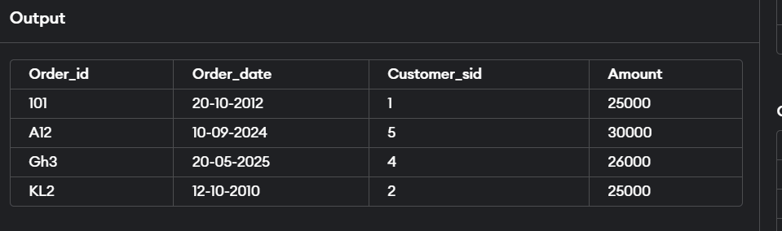

EXPERIMENT 6
Title: Write sql query to show records where amount is increased by 500.
Objective: List the orders where amount is increased by 500 and replace with name “new amount”.
Pre-requisites:
- SQL queries
- DML queries
Query:
select *,Amount as 'New amount' from Orders2;
Output:
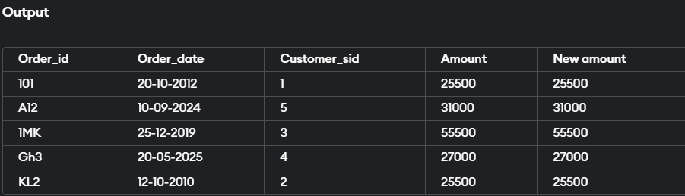

EXPERIMENT 7
Title: Write sql query to show records with their order id and total amount of order done by that order id.
Objective: Display the order_id and total amount of orders
Pre-requisites:
- SQL query
- DML queries
Query:
select Order_id,total(Amount) from Orders2 group by Customer_sid;
Output:
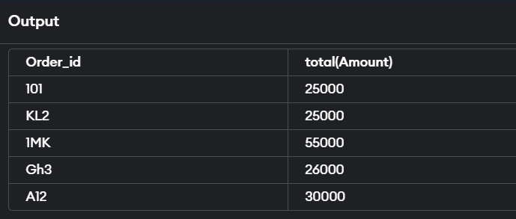

EXPERIMENT 8
Title: Write a sql query to show records where amount is more than 15000.
Objective: Calculate the total amount of orders that has more than 15000.
Pre-requisites:
- SQL query
- DML queries
Query:
Select total(Amount) from Orders2 where amount>15000 group by Customer_sid;
Output:
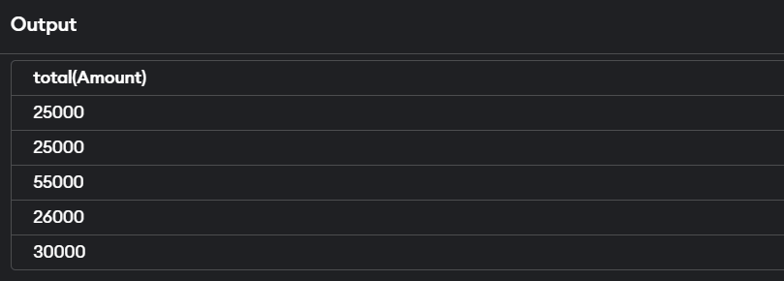

EXPERIMENT 9
Title: Write query to create table Students and Student1.
Objective: Create the following tables
Student
Column_name | Data type | Size | Constraint
RollNo | Varchar2 | 20 | Primary Key
Name | Char | 20
Class | Varchar2 | 20
Marks | Number | 6,2

Student1
Column_name | Data type | Size | Constraint
R_No | Varchar2 | 20 | Primary Key
Name | Char | 20
Class | Varchar2 | 20
Marks | Number | 6,2

Pre-requisites:
- SQL query
- DDL queries
Query:
create table Student(Roll_no varchar(20)primary key,Name char(20),Class varchar(20),Marks int);
create table Student1(R_No varchar(20)primary key,Name char(20),Class varchar(20),Marks int);

Output:
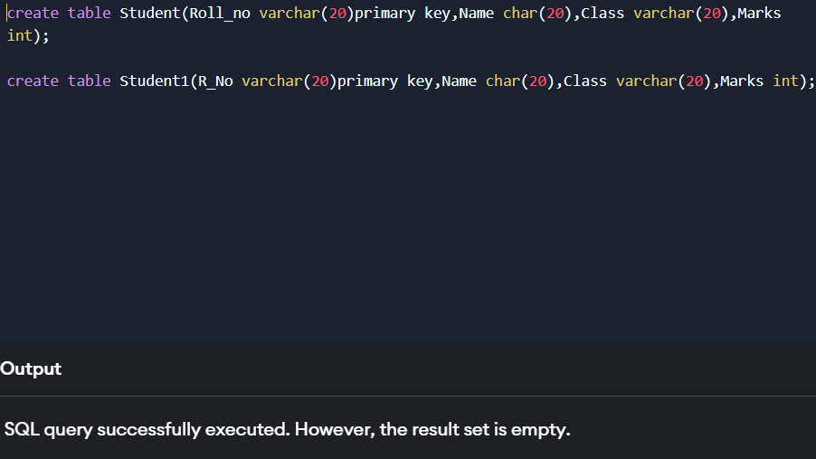

EXPERIMENT 10
Title: Write sql query to display records from student and student1 table.
Objective: Display all the contents of student and student1 using union clause.

Pre-requisites:
- SQL query
- DML queries
Query:
select * from Student
UNION
select * from Student1;
Output:
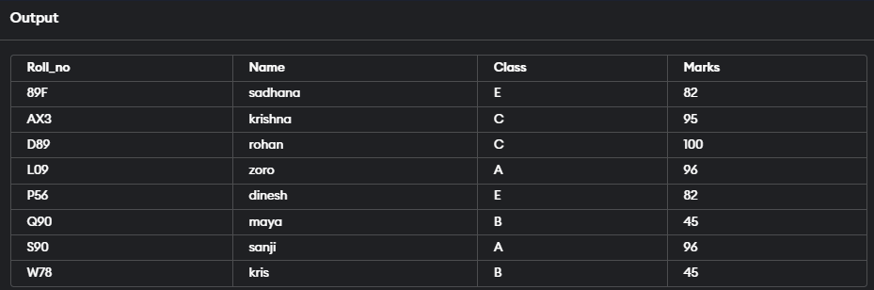

EXPERIMENT 11
Title: Write sql query to show records common in Student and Student1 table.
Objective: Find out the intersection of student and student1 tables.
Pre-requisites:
- SQL query
- DML queries
Query:
select * from Student
INTERSECT
select * from Student1;
Output:
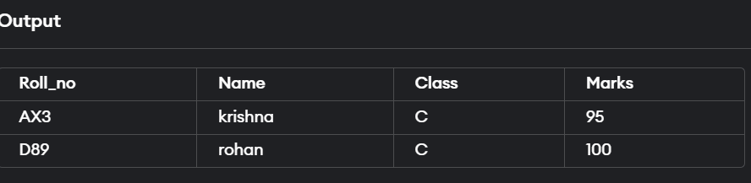

EXPERIMENT 12
Title: write sql queries to show records using different joins.
Objective: Display the names of student and student1 tables using left and inner join.
Pre-requisites:
- SQL query
- DML queries
- JOINS
Query:
LEFT JOIN
SELECT Roll_no FROM Student
LEFT JOIN Student1
ON Student.Roll_no = Student1.R_No;
INNER JOIN
SELECT Roll_no FROM Student
INNER JOIN Student1
ON Student.Roll_no = Student1.R_No;
Output:
LEFT JOIN
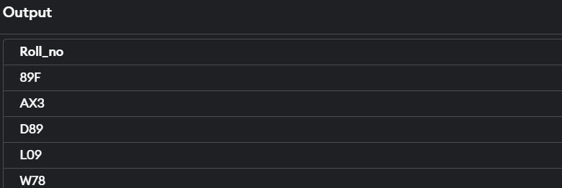

INNER JOIN
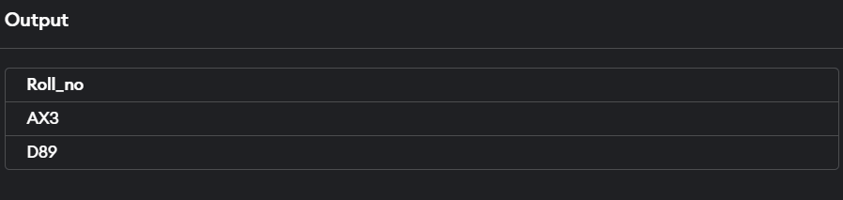

EXPERIMENT 13
Title: PL/SQL queries to calculate
Objective: Write a PL/SQL block to calculate total salary of employee having employee number 100.
Pre-requisites:
- SQl query
- PL/SQL query
Query:
DECLARE
num1 NUMBER;
num2 NUMBER;
num3 NUMBER;
greatest NUMBER;
BEGIN
num1 := 15;
num2 := 25;
num3 := 10;
IF (num1 >= num2 AND num1 >= num3) THEN
greatest := num1;
ELSIF (num2 >= num1 AND num2 >= num3) THEN
greatest := num2;
ELSE
greatest := num3;
END IF;
DBMS_OUTPUT.PUT_LINE('The greatest number is: ' || greatest);
END;

Output:


EXPERIMENT 14
Title: Write pl/sql query to show number from 1 to n
Objective: Write a PL/SQL code to print the numbers from 1 to n.
Pre-requisites:
- SQL query
- PL/SQL queries
Query:
DECLARE
n NUMBER;
BEGIN
n := 10;
FOR i IN 1..n LOOP
DBMS_OUTPUT.PUT_LINE(i);
END LOOP;
END;
Output:
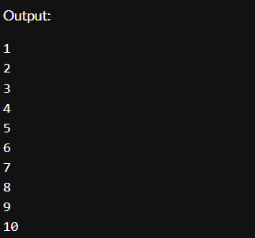

EXPERIMENT 15
Title: PL/SQL query to for reversing string.
Objective: Write a PL/SQL code to reverse a string using for loop.
Pre-requisites:
- SQL query
- PL/SQL queries
Query:
DECLARE
original_string VARCHAR2(100) := 'Hello, World!';
reversed_string VARCHAR2(100) := '';
string_length INTEGER;
BEGIN
string_length := LENGTH(original_string);
FOR i IN REVERSE 1 .. string_length LOOP
reversed_string := reversed_string || SUBSTR(original_string, i, 1);
END LOOP;
DBMS_OUTPUT.PUT_LINE('Original String: ' || original_string);
DBMS_OUTPUT.PUT_LINE('Reversed String: ' || reversed_string);
END;
Output:
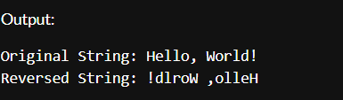

EXPERIMENT 16
Title:PL/SQL command for finding factorial of number.
Objective:. Write a PL/SQL query to find factorial of a number.
Pre-requisites:
- SQL query
- PL/SQL query
PL/SQL queries
Query:
DECLARE
num INTEGER := 5;
factorial INTEGER := 1;
BEGIN
FOR i IN 1 .. num LOOP
factorial := factorial * i;
END LOOP;
DBMS_OUTPUT.PUT_LINE('Factorial of ' || num || ' is: ' || factorial);
END;
Output:
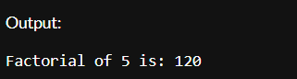

EXPERIMENT 17
Title: PL/SQL command for finding power of number.
Objective: Write a PL/SQL query to find power of a number.
Pre-requisites:
- SQL query
- PL/SQL query
Query:
DECLARE
base NUMBER := 2;
exponent INTEGER := 3;
result NUMBER := 1;
BEGIN
FOR i IN 1 .. exponent LOOP
result := result * base;
END LOOP;
DBMS_OUTPUT.PUT_LINE('Power of ' || base || ' raised to ' || exponent || ' is: ' || result);
END;
Output:
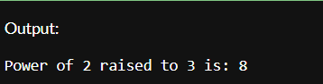

EXERCISE 18
Title: PL/SQL command for finding reverse of string.
Objective: Write a PL/SQL code to reverse a string using for loop.
Pre-requisites:
- SQL query
- PL/SQL query

QUERY:
SET SERVEROUTPUT ON;

DECLARE
original_string VARCHAR2(100) := 'Hello, World!'; -- Input string
reversed_string VARCHAR2(100) := ''; -- Variable to hold the reversed string
string_length INTEGER; -- Length of the original string
BEGIN
-- Get the length of the original string
string_length := LENGTH(original_string);

-- Loop through the original string in reverse order
FOR i IN REVERSE 1..string_length LOOP
-- Concatenate each character to the reversed string
reversed_string := reversed_string || SUBSTR(original_string, i, 1);
END LOOP;

-- Output the reversed string
DBMS_OUTPUT.PUT_LINE('Original String: ' || original_string);
DBMS_OUTPUT.PUT_LINE('Reversed String: ' || reversed_string);
END;
/

OUTPUT:
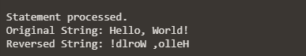

EXERCISE 19
Title: PL/SQL command for finding sum of number.
Objective: Write a PL/SQL code to find suum of n numbers.
Pre-requisites:
- SQL query
- PL/SQL query

QUERY:
DECLARE
n NUMBER; -- Number of elements to sum
num NUMBER; -- Variable to hold each input number
total_sum NUMBER := 0; -- Variable to hold the total sum
BEGIN
-- Prompt for the number of elements
DBMS_OUTPUT.PUT_LINE('Enter the number of elements to sum:');
-- Assume n is provided via some input mechanism, such as a substitution variable or input form
-- For this example, we can assign it directly, or you can modify this part to accept input
n := 5; -- Change this value as needed

FOR i IN 1..n LOOP
-- Prompt for each element - in real applications, you would capture input dynamically
-- Here, for demonstration, we can simulate input:
DBMS_OUTPUT.PUT_LINE('Enter number ' || i || ':');

-- Replace this with your input mechanism
-- For example purposes, we're just prompting and assuming fixed values:
num := i * 10; -- This is just a placeholder, replace it with actual input capture

-- Add the number to the total sum
total_sum := total_sum + num;
END LOOP;

-- Output the result
DBMS_OUTPUT.PUT_LINE('The total sum of the ' || n || ' numbers is: ' || total_sum);
EXCEPTION
WHEN OTHERS THEN
DBMS_OUTPUT.PUT_LINE('An error occurred: ' || SQLERRM);
END;
/
OUTPUT:
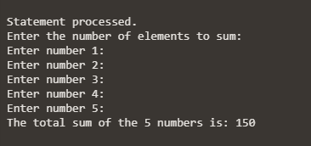

EXERCISE 20
Title: PL/SQL command for display the empno, ename, job of employees of department number 10

Objective: Write a PL/SQL code to consider a PL/SQL code to display the empno, ename, job of employees of department number 10
Pre-requisites:
- SQL query
- PL/SQL query
QUERY
SET SERVEROUTPUT ON;

DECLARE
CURSOR emp_cursor IS
SELECT empno, ename, job
FROM employees
WHERE deptno = 10; -- Filter for department number 10

emp_record emp_cursor%ROWTYPE; -- Record type to hold cursor data
BEGIN
-- Open the cursor and fetch each employee record
OPEN emp_cursor;

LOOP
FETCH emp_cursor INTO emp_record;
EXIT WHEN emp_cursor%NOTFOUND; -- Exit loop when no more records

-- Display the employee details
DBMS_OUTPUT.PUT_LINE('Emp No: ' || emp_record.empno ||
', Name: ' || emp_record.ename ||
', Job: ' || emp_record.job);
END LOOP;

-- Close the cursor
CLOSE emp_cursor;
END;
/
Output:
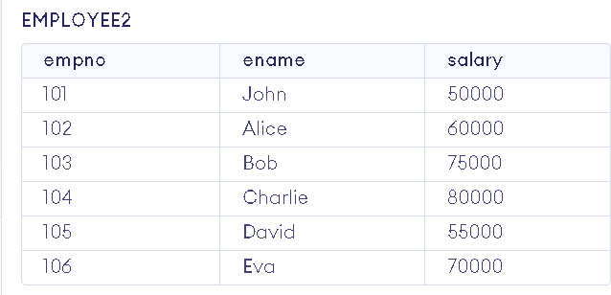
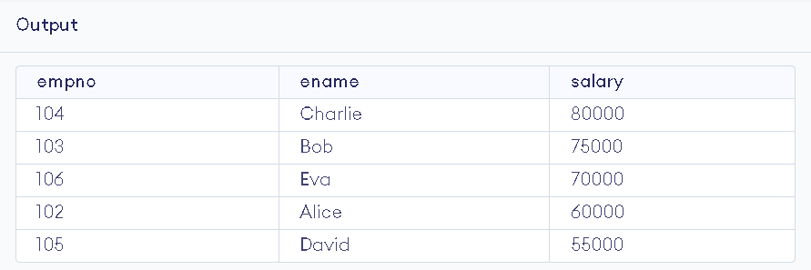

EXERCISE 21
Title: To Consider a PL/SQL procedure that accepts 2 numbers & return addition,
subtraction, multiplication & division of two numbers using stored procedure AND local procedure.

Objective: To Consider a PL/SQL procedure that accepts 2 numbers & return addition,subtraction, multiplication & division of two numbers using stored procedure AND local procedure.
Pre-requisites:
- SQL query
- PL/SQL query
QUERY
SET SERVEROUTPUT ON;

CREATE OR REPLACE PROCEDURE calculate_operations (
p_num1 IN NUMBER,
p_num2 IN NUMBER,
p_add OUT NUMBER,
p_sub OUT NUMBER,
p_mul OUT NUMBER,
p_div OUT NUMBER
) AS
-- Local procedure to perform calculations
PROCEDURE perform_calculations (
num1 IN NUMBER,
num2 IN NUMBER,
add_result OUT NUMBER,
sub_result OUT NUMBER,
mul_result OUT NUMBER,
div_result OUT NUMBER
) IS
BEGIN
add_result := num1 + num2;
sub_result := num1 - num2;
mul_result := num1 * num2;

-- Check for division by zero
IF num2 != 0 THEN
div_result := num1 / num2;
ELSE
div_result := NULL; -- or you can raise an exception
END IF;
END perform_calculations;

BEGIN
-- Call the local procedure to perform calculations
perform_calculations(p_num1, p_num2, p_add, p_sub, p_mul, p_div);
END calculate_operations;
/
Output:


Exercise 22
Title: To Write a PL/SQL block to show the use of NO_DATA FOUND exception
Objective: To Write a PL/SQL block to show the use of NO_DATA FOUND exception Pre-requisites:
- SQL query
- PL/SQL query
QUERY
DECLARE
v_employee_id NUMBER := 100; -- Assuming we are looking for an employee with ID 100
v_first_name VARCHAR2(50);
v_last_name VARCHAR2(50);
BEGIN
-- Attempt to fetch employee details
SELECT first_name, last_name
INTO v_first_name, v_last_name
FROM employees
WHERE employee_id = v_employee_id;

-- Display the employee details if found
DBMS_OUTPUT.PUT_LINE('Employee Found: ' || v_first_name || ' ' || v_last_name);

EXCEPTION
WHEN NO_DATA_FOUND THEN
DBMS_OUTPUT.PUT_LINE('No employee found with ID ' || v_employee_id);
END;
Output
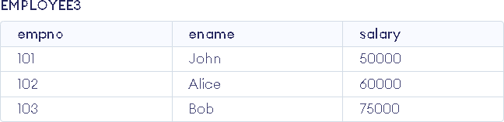
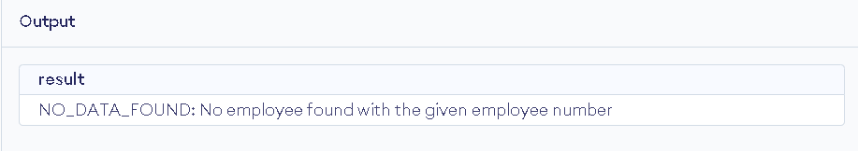

Exercise 22
Title: To Write a PL/SQL block to show use of local function
Objective: To Consider a PL/SQL code that accepts 2 numbers & return addition, subtraction, multiplication & division of two numbers using stored functions and local function.Pre-requisites:
- SQL query
- PL/SQL query
QUERY
CREATE OR REPLACE PACKAGE math_operations AS
FUNCTION add_numbers(num1 NUMBER, num2 NUMBER) RETURN NUMBER;
FUNCTION subtract_numbers(num1 NUMBER, num2 NUMBER) RETURN NUMBER;
FUNCTION multiply_numbers(num1 NUMBER, num2 NUMBER) RETURN NUMBER;
FUNCTION divide_numbers(num1 NUMBER, num2 NUMBER) RETURN NUMBER;
END math_operations;
/
CREATE OR REPLACE PACKAGE BODY math_operations AS

FUNCTION add_numbers(num1 NUMBER, num2 NUMBER) RETURN NUMBER IS
BEGIN
RETURN num1 + num2;
END add_numbers;

FUNCTION subtract_numbers(num1 NUMBER, num2 NUMBER) RETURN NUMBER IS
BEGIN
RETURN num1 - num2;
END subtract_numbers;

FUNCTION multiply_numbers(num1 NUMBER, num2 NUMBER) RETURN NUMBER IS
BEGIN
RETURN num1 * num2;
END multiply_numbers;

FUNCTION divide_numbers(num1 NUMBER, num2 NUMBER) RETURN NUMBER IS
BEGIN
IF num2 = 0 THEN
RAISE_APPLICATION_ERROR(-20001, 'Division by zero is not allowed');
END IF;
RETURN num1 / num2;
END divide_numbers;

END math_operations;
/
DECLARE
num1 NUMBER;
num2 NUMBER;
result_add NUMBER;
result_subtract NUMBER;
result_multiply NUMBER;
result_divide NUMBER;
BEGIN
-- Accepting two numbers; these values can be taken from user input or hardcoded
num1 := 10; -- Example value
num2 := 5; -- Example value

-- Calling the stored functions from the package
result_add := math_operations.add_numbers(num1, num2);
result_subtract := math_operations.subtract_numbers(num1, num2);
result_multiply := math_operations.multiply_numbers(num1, num2);

-- Handle division with exception
BEGIN
result_divide := math_operations.divide_numbers(num1, num2);
EXCEPTION
WHEN OTHERS THEN
DBMS_OUTPUT.PUT_LINE(SQLERRM);
END;

-- Display the results
DBMS_OUTPUT.PUT_LINE('Addition: ' || result_add);
DBMS_OUTPUT.PUT_LINE('Subtraction: ' || result_subtract);
DBMS_OUTPUT.PUT_LINE('Multiplication: ' || result_multiply);
DBMS_OUTPUT.PUT_LINE('Division: ' || result_divide);
END;
/

Output
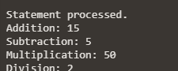

Exercise 23
Title: To Write a PL/SQL block to show use of TOO MANY ROWS
Objective: To Write a PL/SQL block to show the use of TOO_MANY ROWS exception
Pre-requisites:
- SQL query
- PL/SQL query
Query
SET SERVEROUTPUT ON;

DECLARE
v_deptno NUMBER := 10; -- Change this to a department number that has multiple employees
v_ename VARCHAR2(100);
BEGIN
-- Attempt to select the employee name based on department number
SELECT ename INTO v_ename
FROM employees
WHERE deptno = v_deptno;

-- If the employee is found, display the name
DBMS_OUTPUT.PUT_LINE('Employee Name: ' || v_ename);

EXCEPTION
WHEN TOO_MANY_ROWS THEN
-- Handle the exception when too many rows are found
DBMS_OUTPUT.PUT_LINE('Error: More than one employee found in department number: ' || v_deptno);
WHEN NO_DATA_FOUND THEN
-- Handle the exception when no data is found
DBMS_OUTPUT.PUT_LINE('No employee found in department number: ' || v_deptno);
WHEN OTHERS THEN
-- Handle any other exceptions
DBMS_OUTPUT.PUT_LINE('An unexpected error occurred: ' || SQLERRM);
END;
/

Output
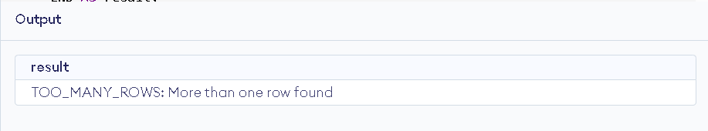

Exercise 24
Title: To Write a PL/SQL block to show use of ZERO DIVIDE
Objective: Write a PL/SQL block to show the use of ZERO_DIVIDE exception
Pre-requisites:
- SQL query
- PL/SQL query
Query
DECLARE
numerator NUMBER := 10;
denominator NUMBER := 0; -- Set this to 0 to trigger the ZERO_DIVIDE exception
result NUMBER;
BEGIN
-- Attempt to perform the division
result := numerator / denominator;
DBMS_OUTPUT.PUT_LINE('Result: ' || result);
EXCEPTION
WHEN ZERO_DIVIDE THEN
DBMS_OUTPUT.PUT_LINE('Error: Division by zero is not allowed.');
WHEN OTHERS THEN
DBMS_OUTPUT.PUT_LINE('An unexpected error occurred: ' || SQLERRM);
END;

Output
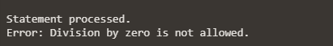

Exercise 25
Title: To Write a PL/SQL block to show audit of table.
Objective: To create a trigger on the emp table, which store the empno& operation in the table auditor for each operation i.e. Insert, Update & Delete.

Pre-requisites:
- SQL query
- PL/SQL query
Query
CREATE TABLE auditor (
audit_id NUMBER GENERATED BY DEFAULT AS IDENTITY PRIMARY KEY,
empno NUMBER,
operation VARCHAR2(10),
operation_time TIMESTAMP DEFAULT CURRENT_TIMESTAMP
);
CREATE OR REPLACE TRIGGER trg_audit_emp
AFTER INSERT OR UPDATE OR DELETE ON emp
FOR EACH ROW
BEGIN
IF INSERTING THEN
INSERT INTO auditor (empno, operation)
VALUES (:NEW.empno, 'INSERT');
ELSIF UPDATING THEN
INSERT INTO auditor (empno, operation)
VALUES (:NEW.empno, 'UPDATE');
ELSIF DELETING THEN
INSERT INTO auditor (empno, operation)
VALUES (:OLD.empno, 'DELETE');
END IF;
END trg_audit_emp;
/
-- Insert a new employee
INSERT INTO emp (empno, ename, job, mgr, hiredate, sal, comm, deptno)
VALUES (1, 'John Doe', 'Developer', NULL, SYSDATE, 50000, NULL, 10);

-- Update the employee
UPDATE emp
SET sal = 55000
WHERE empno = 1;

-- Delete the employee
DELETE FROM emp
WHERE empno = 1;

-- Check the auditor table
SELECT * FROM auditor;

Output

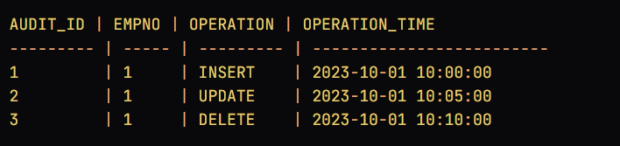
Exercise 26
Title: To Write a PL/SQL block to no operation code.
Objective: To create a trigger so that no operation can be performed on emp table

Pre-requisites:
- SQL query
- PL/SQL query
Query
CREATE OR REPLACE TRIGGER trg_prevent_emp_operations
BEFORE INSERT OR UPDATE OR DELETE ON emp
BEGIN
RAISE_APPLICATION_ERROR(-20001, 'No operations are allowed on the emp table.');
END trg_prevent_emp_operations;
/
-- Attempt to insert a new employee
INSERT INTO emp (empno, ename, job, mgr, hiredate, sal, comm, deptno)
VALUES (1, 'John Doe', 'Developer', NULL, SYSDATE, 50000, NULL, 10);
